FBYZR7031 Yapay Zeka’da İstatistiki Metodlar I ve FBYZR7028 Yapay Zeka’da İstatistiki Metodlar II dersler için kısa kısa okuma notları (Güncellenecektir )

İstatistik ve Bilgisayar Biliminde kullanılan kavramlar ve açıklamaları
Statistics | Computer Science | Explanations
Data point | Example/instance
Variable selection | Feature selection
Estimation | Learning | In the context of developing a model, use data to estimate (or learn) unknown quantity or parameters of the model,although the keyword ‘learning’ is an umbrella term in computer science that also means prediction etc
Classification | Supervised learning | Predicting a discrete y from X
Type I and Type II errors | False positive and false negative | Nature of errors made by a classification rule/model
Regression | Supervised learning | Predicting a continuous y from X
Fitting | Learning | Terms used by the respective communities to describe model buildingb
Test set performance | Generalization | Terms used by the respective communities to assess model performance on  data different from that used to develop the modelb
Clustering, anomaly detection, principal component analysis | Unsupervised Learning | Putting data into groupsª
Dependent variable | Label (or Target) | The yi ’s
Covariates or predictors | Features | The Xi ’s
Classifier | Hypothesis | Map from covariates to outcome
Bayesian inference | Bayesian inference | Statistical methods for using data to update probability
Directed acyclic graph | Bayesian net | Multivariate distribution with conditional independence relations
Statistical consistency large deviation bounds | Probably approximately correct (PAC) learning | Uniform bounds on probability of errors
Sequential analysis | On-line learning | Receives data sequentially. Learn or predict an incoming stream of observations, one sample at a time.
Class of models (M) | Hypothesis class (F) | Set of models like logistic regression for binary classification problem

Kaynak : Rajiv Sambasivan, R,Das, S., Sahu,S. A Bayesian perspective of statistical machine learning for big data https://link.springer.com/article/10.1007/s00180-020-00970-8

Machine Learning Scheme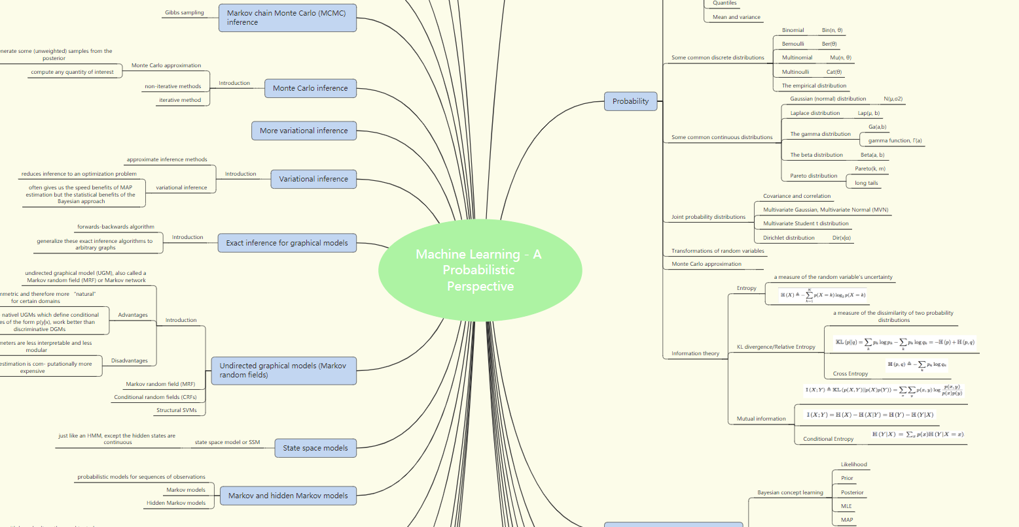
https://www.xmind.net/m/T9Nm/

Videolar :
Mode, Median,Mean,Range, SDeviation : | https://www.youtube.com/watch?v=mk8tOD0t8M0
Histogram : | https://www.youtube.com/watch?v=qBigTkBLU6g
P values : | https://www.youtube.com/watch?v=5Z9OIYA8He8
Z-Scores, Standardization, and the Standard Normal Distribution : | https://www.youtube.com/watch?v=2tuBREK_mgE
Bias and MSE | https://www.youtube.com/watch?v=XqWfeND04vs
Probability vs likelihood : | https://www.youtube.com/watch?v=pYxNSUDSFH4
Maximum Likelihood : | https://www.youtube.com/watch?v=XepXtl9YKwc
ML for Normal Distribution : | https://www.youtube.com/watch?v=Dn6b9fCIUpM
Gradian Descent: | https://www.youtube.com/watch?v=sDv4f4s2SB8

Notlar :

Machine Learning — Probability & Statistics : https://towardsdatascience.com/machine-learning-probability-statistics-f830f8c09326

Statistics & Probability Basics for Machine Learning — Part 1 : https://medium.com/@falgunimukherjee/statistics-probability-basics-for-machine-learning-part-1-e811891156c3

Stanford CS 229 — Makine Öğrenmesi, CS 230 — Derin Öğrenme ve CS 221 — Yapay Zeka El Kitapları Artık Türkçe : https://medium.com/yavuzkomecoglu/stanford-cs-229-makine-%C3%B6%C4%9Frenmesi-ve-cs-230-derin-%C3%B6%C4%9Frenme-el-kitaplar%C4%B1-art%C4%B1k-t%C3%BCrk%C3%A7e-ed734ad76bed

Elements of Probability and Statistics (Temel İstatistik Dersnotları ) ODTU : https://ocw.metu.edu.tr/course/view.php?id=83

İstatistiksel Öğrenme II – Modelin Netliğini Değerlendirme: https://mertricks.com/2015/05/30/modelin-netligini-degerlendirme/
Forecast KPI: RMSE, MAE, MAPE & Bias : https://medium.com/analytics-vidhya/forecast-kpi-rmse-mae-mape-bias-cdc5703d242d

Cross Entropy : https://veribilimcisi.com/2018/05/04/log-kaybi-ve-capraz-entropi-log-loss-and-cross-entropy/

Understanding Kalman Filters with Python : https://medium.com/@jaems33/understanding-kalman-filters-with-python-2310e87b8f48
Ridge ve Lasso Regresyon : https://medium.com/kaveai/ridge-ve-lasso-regresyonu-temel-matemati%C4%9Fi-ve-python-uygulamas%C4%B1yla-363916e32d8d

